HD 169830

HD 169830 is a 1.4 M☉, F8 V star1. Based on 112 RV CORALIE measurements obtained between 1999 and 2003, a study performed in 2004 (hereafter M04)2 reported a GP (HD 169830b) with a period of 225.62 ± 0.22 days, a minimum mass of 2.88 MJup and an eccentricity of 0.31 ± 0.01 as well as a LPGP (HD 169830c) signal with a period of 2102 ± 264 days, a minimum mass of 4.04 MJup and an eccentricity of 0.33 ± 0.02. The CH survey reported the same results as presented in the M04 study.

In the present study, in addition to the M04’s dataset[1], 75 RV HIRES measurements obtained between 2000 and 2014 and 86 RV HARPS measurements obtained between 2004 and 2009 were considered. DPASS and MCMC (1000 walkers and 300000 iterations) to fit the data. The properties of planets b and c are close to those reported in the CH survey.

The fits are shown in Fig 1, and the corner plot in Fig 2, and the results summarized in Table 1.

Note that, recently, combining RV and Hipparcos/Gaia absolute astrometry data, a study performed in 20223 reported, for HD 169830b, properties close to those reported in the CH survey and were able to estimate the orbital inclination, and thus the true mass, of HD 169830c. They found a period of days, an eccentricity of 0.25 ± 0.02, an inclination of °, and a mass of MJup.

Conclusion: the properties found in the CH survey for both planets are confirmed. 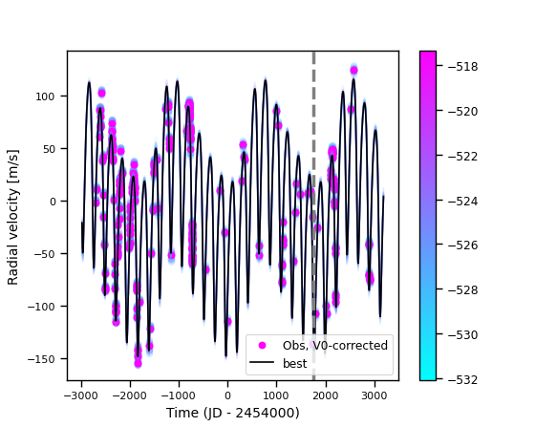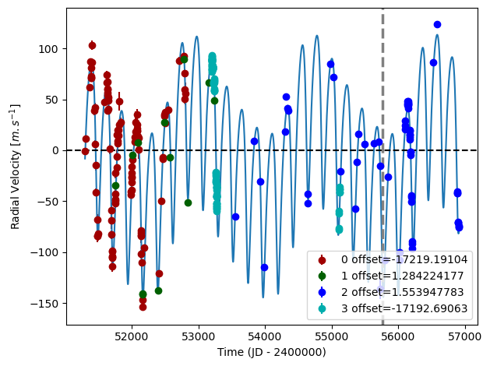

Figure 1: Left: fit of the HD 169830 RV with DPASS. Red - C98, green - Hir94, blue - Hir04, cyan - H03. The blue curve shows the best fit. Right: fit of the HD 169830 RV using MCMC. The black curve shows the best fit. The colorbar corresponds to the log-likelihood of the fits. The gray dotted line indicates the end of the CH survey.

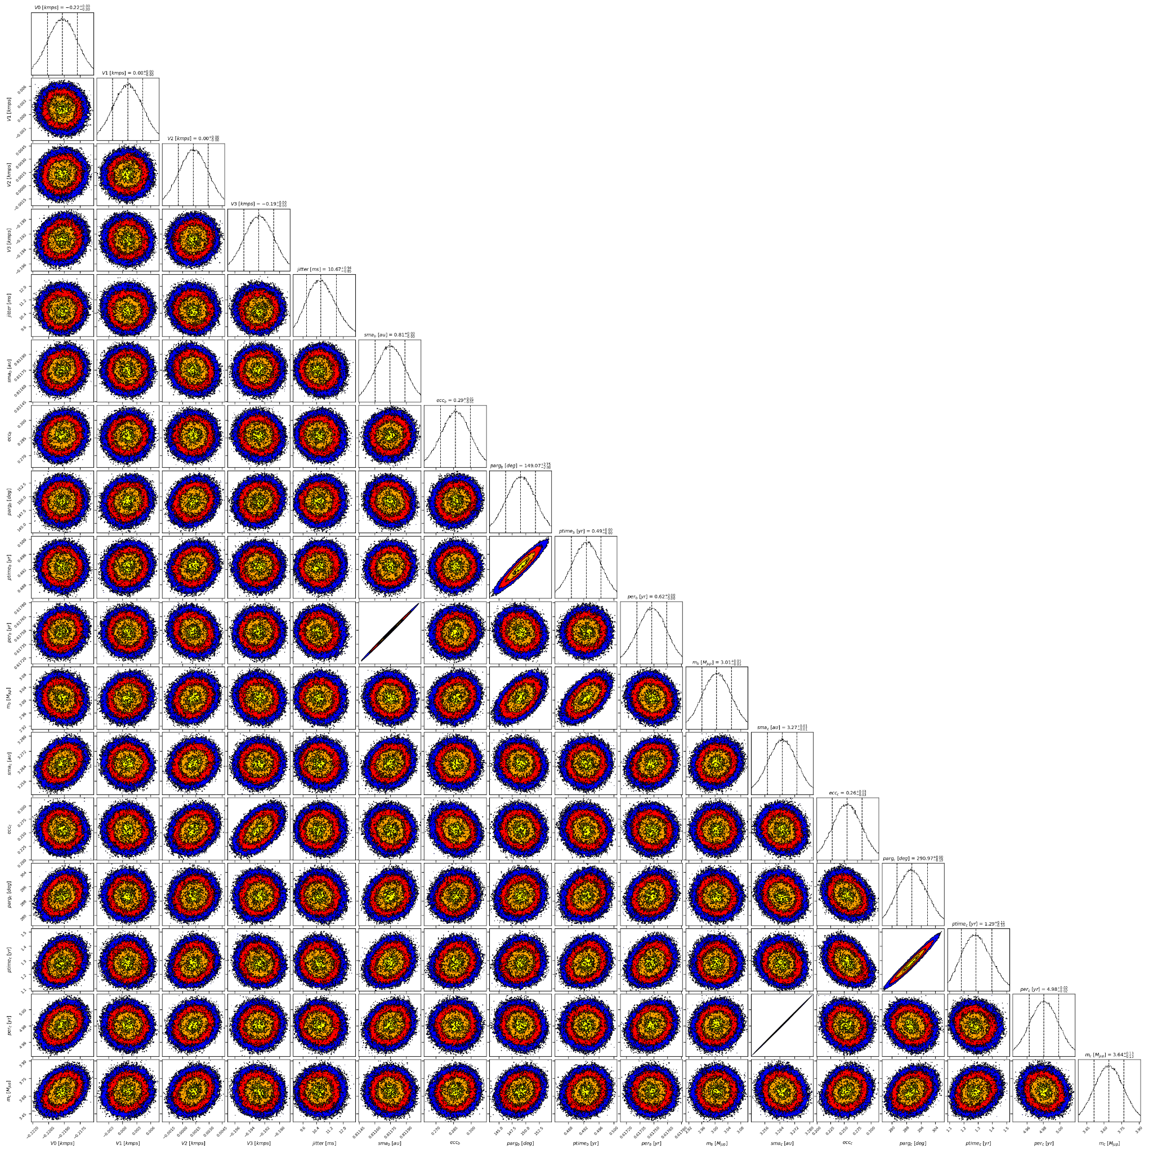

Figure 2: Corner plot of posteriors for the two-planets model MCMC fit of HD 169830 RV data.

| Parameter | Priors | | Posteriors | | CH survey |
| --- | --- | --- | --- | --- | --- |
|  | DPASS | MCMC | DPASS | MCMC |  |
| *a* (au) | b: [0,80]  c: [0,80] | b: [0.5,1.5]  c: [2,10] | b = 0.81  c = 3.27 | b = 0.81 ± 0.01  c = 3.27 ± 0.01 | b = 0.81  c = 3.6 |
| Msin(i) (MJup) | b: [0,100]  c: [0:100] | b: [2,4]  c: [2,10] | b = 2.9  c = 3.5 | b = 3.01 ± 0.05  c = | b = 2.88  c = 4.04 |
| Eccentricity | b: [0,0.95]  c: [0,0.95] | b: [0.2,0.4]  c: [0,0.5] | b = 0.29  c = 0.26 | b =  c = | b = 0.31  c = 0.33 |
| Instrumentals offsets (km/s) | [-60,60] | C98: [-18,-16]  Hir94: [-1,1]  Hir04: [-1,1]  H03: [-18,-16] | C98: -17.219  Hir94: 0.001  Hir04: 0.002  H03: -17.193 | C98: -17.219± 0.002  Hir94:  Hir04:  H03: -17.193 ± 0.002 |  |
| Stellar jitter (m/s) | [0,40] | [0,40] | 9.7 | 10.7 ± 0.9 |  |
| Argument of periastron (°) | b: [0,360]  c: [0,360] | b: [0,360]  c: [0,360] | b = 147  c = 302 | b = 149± 3  c = |  |
| Phase | b: [0,1]  c: [0,1] | b: [0,1]  c: [0,1] | b = 0.71  c = 0.89 | b = 0.80± 0.01  c = 0.26± 0.02 |  |

Table 1: HD 169830. Summary of priors and posteriors obtained with DPASS and MCMC, compared to the properties reported by the CH Survey.

References

1. Fischer, D. and Valenti, J. The Planet-Metallicity Correlation. *Astrophys. J.* 622, 1102-1117 (2005).
2. Mayor, M. et al. The CORALIE survey for southern extra-solar planets XII. Orbital solutions for 16 extra-solar planets discovered with CORALIE. *Astron. Astrophys.* 415, 391-402 (2004).
3. Feng, F. et al. 3D Selection of 167 Substellar Companions to Nearby Stars. *Astrophys. J. Supp. Ser.* 262, 21 (2022).

1. The CORALIE data used were not available on the CDS database; therefore these data were recovered from DACE but they are not exactly the same as those used by the M04 study2 (106 RV CORALIE data against 112 RV CORALIE data). Yet, the RV curve obtained for the CORALIE dataset was the same.